Participation of Humans in Research
Significant Risk Project

If your project involves collecting data from humans and is considered Significant Risk, it must comply with WMSF Policy Participation of Humans in Research – Significant Risk. Your project involves conditions where the risks of harm are greater or more likely than those encountered in everyday life.

Before you begin working on your project:

- You must submit a Research Plan to WMSF for approval
  - Your Adult Supervisor and Scientific Supervisor should review this plan before you submit it. If your project involves Drugs, Invasive Procedures and Bodily Tissues, or Ingestion (Significant Risk), it must be carried out in a Hospital, University, Medical or other similar Laboratory under the direction of your Scientific Supervisor. The experiment must be approved by the appropriate Scientific Review/Ethics Committee that reviews the research at that Institution, and this must be documented in a letter that is attached to this Research Plan that you submit to WMSF.
- Your project must have an Adult Supervisor who must complete and sign Form PHSR - Certificate of Compliance
- Significant Risk projects require a Scientific Supervisor who must also sign the Form PHSR. The Scientific Supervisor may need to have certain qualifications depending on the project. The Scientific Supervisor can also be the Adult Supervisor.
- Participants (or their parents/guardians if they are under 18) must be provided with a Letter of Information before they participate. Include your Letter of Information when you submit your Research Plan to WMSF for approval.
- Participants must sign a Permission Form before they participate
- For Significant Risk Exercise projects, Participants must also sign a Physical Exercise Permission Form. You can combine this into your Permission Form if you like.

You must create the Letter of Information and Permission Form for your project. This booklet contains templates that you can use to create these documents. It also includes instructions.

Table of Contents

Page 1 Research Plan template
Page 2 Form PHSR – Certification of Compliance
Page 3 Letter of Information template
Page 4 Instructions for completing Letter of Information
Page 5 Permission Form template
Page 6 Physical Exercise Permission Form (for exercise projects only)

If you are entering the Western Manitoba Science Fair, please attach the following to your entry form so the judges can review them:
- A copy of the signed Form PHSR
- A copy of your Letter of Information
- A blank copy of your Permission Form
  - Do NOT submit the signed permission forms that you collect from your participants to WMSF. Keep those in a safe place until the science fair is over and you think you no longer need them. If you move on to the Canada Wide Science Fair you would keep them until after that fair. You are keeping these signed permission forms as proof that you informed your participants about the details of your project and that they agreed to participate.
- If you gave your Participants a survey as a part of your project, attached a blank copy of your survey questions.

Tip: It is a good idea to have the above documents available for judges at your school fair as well. They might not be familiar with WMSF rules or Policy, but they will be impressed at your thoroughness!
Research Plan Template
Human Participation Significant Risk Project

Adult and Scientific Supervisor(s)
 | First Name | Last Name | Email | Phone
Adult Supervisor
Scientific Supervisor*
Additional Mentors

*Your Scientific Supervisor must be qualified to support you in the area of STEM you are working in. Please refer to the WMSF Policy Participation of Humans in Research – Significant Risk for more information. If your Scientific Supervisor is required to have certain qualifications, please record them here:

Data Collection
Start Date
End Date

Location
Where will you be collecting your data?

Idea and Purpose
Explain briefly what your project is about. What is your idea looking to achieve?

Method or Procedure
Explain the general procedure you will be using.

Risks and Safety
List the potential risks and safety concerns associated with your project, and how you are addressing them.

Is this a continuation of a previous project?
If so, give a brief summary of the previous project and why you have decided to continue it.
Form PHSR: Participation of Humans
Significant Risk – Certification of Compliance
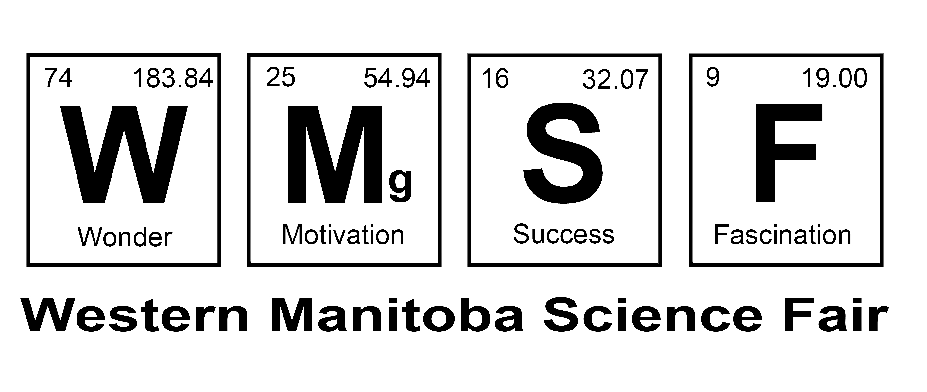

This form certifies that a significant risk project involving the participation of humans is in full compliance with WMSF Policy Participation of Humans in Research – Significant Risk. https://www.wmsf.com/ethics/srpolicy

Project Title
 | First Name | Last Name | Email | Phone
Student 1
Student 2
Adult Supervisor
Scientific Supervisor
Chairperson, WMSF | Trevor | Maguire | info@wmsf.com | 204-761-0400
Judging Chair, WMSF | Robyn | Forsman | judging@wmsf.com | 204-570-0271

The following project documents must be available to the Adult Supervisor and Scientific Supervisor, prior to them signing this form:
  - Your Research Plan
  - Your Letter of Information that will be given to every participant in your survey
  - A blank sample of the Permission Form that each participant will sign
  - Your list of survey questions if your project includes a survey

Acknowledgement by Student Researcher(s):

I have read and understand WMSF Policy Participation of Humans in Research – Significant Risk
https://www.wmsf.com/ethics/srpolicy.

Signed - Student 1 Date Signed - Student 2 Date

Certification by Adult Supervisor and Scientific Supervisor:

I have read and understand WMSF Policy Participation of Humans in Research – Significant Risk, and I certify that this Project involving Human Participation is in full compliance with said Policy and that it is eligible for the Western Manitoba Science Fair.

Signed – Adult Supervisor Date Signed – Scientific Supervisor Date

Letter of Information

Insert Project Title Here

- Researcher and Advisors

 | First Name | Last Name | Phone | Email
Student 1
Student 2
Adult Supervisor
Scientific Supervisor
School

- Purpose of the Research

- Benefits from Participating

- Risks from Participating

- Time Commitment Required

- Remuneration

- Confidentiality of Data

- Withdrawing from the project

- Results

Instructions for completing your Letter of Information

- Researcher and Advisors
Give the name(s) of the researcher(s); school; project title; the Adult Supervisor’s name, Scientific Supervisor’s name, email address and telephone number.

- Purpose of the Research
Describe the purpose of this research.

- Benefits from Participating
Define the benefits to the participant from participating.

- Risks from Participating
Discuss the risks to the participant from participating.

- Time Commitment Required
Give the time each participant will contribute to the project.

- Remuneration
Must state that there will be no remuneration paid for participation in this project.

- Confidentiality of Data

How will the confidentiality of the data be guaranteed?

- Withdrawing from the Project
Explain that each participant has the right to withdraw from the project at any time, and for any reason.

- Results
Explain how the results of the research will be communicated to the participant

- Other info
Include any other relevant info that you feel the participants should have.

Distribution

Give a copy of your Letter of Information to each of the participants in your study before they participate.

Western Manitoba Science Fair: Submit a copy of this letter with your entry form, and have a copy of this letter at your project.

Permission Form

Project Title:

I have received the Letter of Information for this Science Fair Project, which is mine to keep. All my questions have been answered to my satisfaction, and I agree to participate in this research.

Name of Participant (print):

Signature of Participant: _________________________________

Date:

Name of Parent of Guardian¹:

Signature of Parent of Guardian: _____________________________

Date:

Name of person obtaining consent (Student Researcher):

Signature of person obtaining consent: ___________________________

Date:

¹ If the participant is under the age of 18, then a parent or guardian must also give permission by signing this form.
This completed form contains personal information and must be stored securely. All Informed Consent Permission Forms must be shredded after the project is no longer needed for Science Fairs.

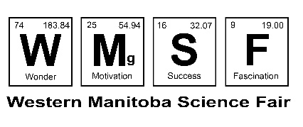
Physical Exercise Permission Form

Participating in physical activity is very safe for most people. To see whether you are eligible to participate in physical activity as part of a STEM project, please read the next section carefully.

Do any of the following apply to you?
- You have a heart condition OR high blood pressure
- You feel pain in your chest at rest, during your daily activities of living, OR when you do physical activity
- You lose balance because of dizziness OR have you lost consciousness in the last 12 months
- You have another chronic medical condition (other than heart disease or high blood pressure)
- You are taking prescribed medications for a chronic medical condition
- In the last 12 months, you had a bone, joint, or soft tissue (muscle, ligament, or tendon) problem that could be made worse by becoming more physically active (this does not apply if you had a problem in the past, but it does not limit your current ability to be physically active)
- Your doctor has said you should only do medically supervised physical activity
- You are pregnant

If you are no longer interested in participating, or if any of the above apply to you, you are NOT eligible to participate in this project. Your name and signature are not required, and you can excuse yourself from the activity. You do not need to provide a reason why. Thank you for your time, interest in participating, and for supporting youth in STEM.

If none of above apply to you, then you are eligible to participate in this project. Please complete the rest of this form and return it to the student(s) running the project. Thank you for your time, participation, and for supporting youth in STEM.

Participant Declaration

I, the undersigned, have carefully read and understood the list of medical conditions that would exclude me from participating. None of those apply to me at this time. I acknowledge that this physical activity clearance is valid for the length of this project (but no longer than a year) and becomes invalid if my condition changes.

If you are under 18 years of age, your parent or guardian must also sign this form.

Name: ________________________________ Date: ______________________

Signature: _____________________________

Signature of parent or guardian (if under 18 years of age): _____________________

